Intelligent Cognitive Alarm Platform
- Cognitive Challenges & Verification System

G. SAI SOUMYA SRI

Table of Contents

1. Project Description | 1
2. Environment Setup | 1
3. Modules Implemented | 2
4. System Architecture / Workflow | 3
5. Implementation Details | 3
6. Testing & Results | 4
7. Evaluation Metrics | 5-11
8. Conclusion | 12

1.Project Description
The Intelligent Cognitive Alarm Platform (ICAP) is an AI-powered alarm system that requires users to solve personalized cognitive challenges before dismissing an alarm, aiming to build consistent wake-up habits. Milestone 2 focuses on building the Cognitive Challenge Engine, the Wake-Up Verification Module, and the underlying analytics that measure challenge performance.

2.Environment Setup
The backend was developed using Python 3.x with FastAPI as the core web framework, chosen for its async support, automatic OpenAPI documentation (Swagger UI), and strong integration with Pydantic for request/response validation. SQLAlchemy was used as the ORM layer to define database models and manage queries against a PostgreSQL database hosted on Supabase, which also handles authentication-adjacent infrastructure for the project.
Development was carried out locally on Windows using VS Code as the IDE. Since curl is aliased differently in PowerShell, all manual API testing was performed using Invoke-WebRequest, with Swagger UI (/docs) used in parallel for quick visual testing and request/response inspection. JWT-based authentication was required for protected routes, meaning test tokens had to be refreshed roughly every 60 minutes during development sessions

Key libraries and their roles:
- FastAPI — defines all REST endpoints (routers) and handles request routing, validation errors, and automatic documentation
- SQLAlchemy — ORM layer mapping Python classes to PostgreSQL tables (Challenge, AlarmTrigger, ChallengeAttempt)
- Pydantic — enforces strict schema validation on every request and response body, catching malformed input before it reaches business logic
- PostgreSQL (Supabase) — hosts all relational data; used here specifically for persisting generated challenges, verification attempts, and trigger records
- python-jose / JWT — used indirectly via the auth system from Milestone 1 to protect challenge and verification endpoints

3. Modules Implemented

Cognitive Challenge Engine
Generates personalized challenges across 7 distinct categories, each implemented as its own module under app/services/challenge_service/: Math Problems, Logic Puzzles, Memory Challenges (including image sequence recall), Word Games (themed around peaceful/motivated/energetic/joyful words to match the app's morning-motivation tone), Pattern Recognition, Riddles, and Quick Quizzes. A central engine.py orchestrates category selection and delegates puzzle generation to the relevant module, keeping each category's logic isolated and independently testable.
Wake-Up Verification Module
Bridges the gap between "an alarm went off" and "the user is actually awake and alert." It creates an AlarmTrigger record the moment an alarm fires, generates an associated challenge, and then validates the user's submitted answer — logging every attempt (correct or incorrect) to a challenge_attempts table and updating the trigger's overall verification status accordingly.

Challenge Analytics
Aggregates performance data across all logged attempts, surfacing both overall and per-category statistics — total attempts, correct/incorrect counts, and accuracy percentage. This data is intended to eventually feed into the Adaptive Difficulty Engine (Milestone 3), so it was built with that downstream use in mind.

4. System Architecture / Workflow
Challenge Generation Flow:
When an alarm fires, the client calls GET /challenges/generate. This hits app/routers/challenges.py, which delegates to challenge_service/engine.py. The engine first calls the difficulty service to determine the appropriate difficulty level for the user (based on their recent performance), then selects a category — weighted by the user's stated goal type (study, work, or fitness) — and invokes that category's generation module (e.g. math_problems.py). The generated puzzle, along with its correct answer and metadata, is persisted to the challenges table in Postgres before being returned to the client.
Verification Flow:
POST /verify/trigger is called when an alarm goes off; it creates an AlarmTrigger row and generates a fresh challenge in the same call, so the user immediately has something to solve. Once the user submits an answer, POST /verify/attempt is called: the verification service compares the submitted answer against the stored correct answer (case-insensitively), logs the outcome to challenge_attempts, and updates the trigger's verification_status and total_attempts fields. This design allows multiple attempts per trigger, supporting a "must get it right to dismiss" flow rather than a single pass/fail check.

5. Implementation Details
- All 7 challenge category modules follow an identical interface (generate() and verify(answer)), which made it straightforward to add new categories without touching the core engine logic
- Answer verification is case-insensitive across every category to avoid rejecting technically-correct answers due to casing
- Category selection is personalized: the engine weights category probability based on the user's goal_type field from their profile, so a "study"-focused user sees more logic/pattern challenges while a "fitness"-focused user might see more quick quizzes
- The difficulty_service (built as part of this phase, feeding into Milestone 3) calculates a difficulty tier — beginner through expert — based on the user's rolling accuracy over their last 10 attempts, and this difficulty is stamped directly onto each newly generated challenge
- Memory challenges' image sequence recall subtype currently uses hardcoded Unsplash image URLs as a placeholder; a production version would require dedicated image storage (S3 or Supabase Storage/Blob) to serve custom, non-repeating images
- Recurring implementation issues encountered and resolved: stray characters from copy-pasted code, accidental import deletions when merging new router files into main.py, and forgetting to register new SQLAlchemy models in Base.metadata.create_all()

6. Testing & Results
All endpoints were tested end-to-end using both Swagger UI and PowerShell's Invoke-WebRequest, since PowerShell requires a try/catch wrapper to surface non-2xx response bodies (which Invoke-WebRequest otherwise suppresses by throwing an exception).
- GET /challenges/generate — tested across all 7 categories individually; confirmed each returns a correctly structured puzzle and persists a matching row in the Supabase challenges table, including the correct difficulty tag
- POST /verify/trigger and POST /verify/attempt — tested both the correct-answer path (trigger marked verified) and incorrect-answer path (attempt logged, trigger remains unverified, retry allowed); confirmed challenge_attempts rows are created accurately for both outcomes
- GET /challenges/stats — confirmed accurate aggregation of total attempts, correct/incorrect breakdown, and accuracy percentage, both overall and filtered per category
- Authentication was verified as a prerequisite for all challenge/verification routes — unauthenticated requests correctly receive a 401/403 response before reaching business logic
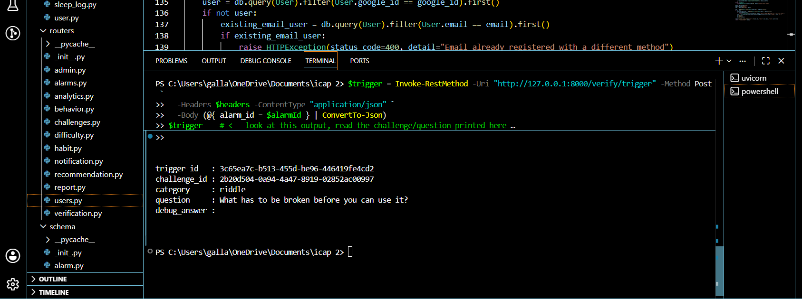
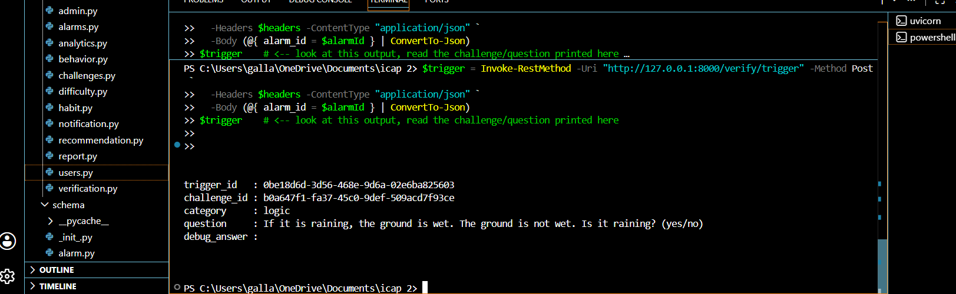

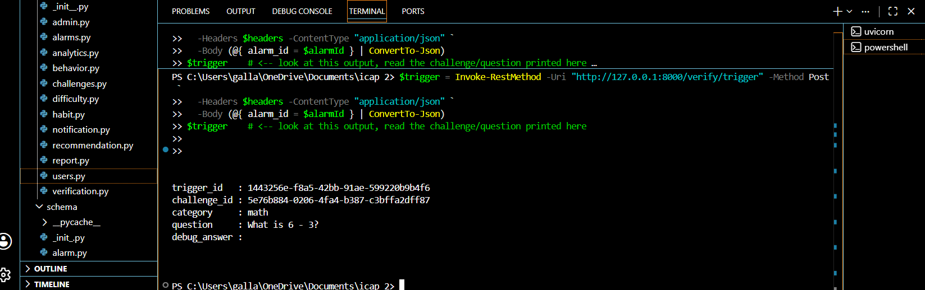

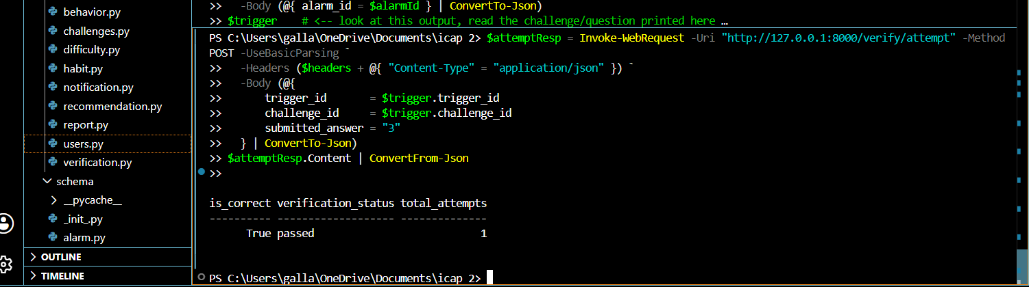

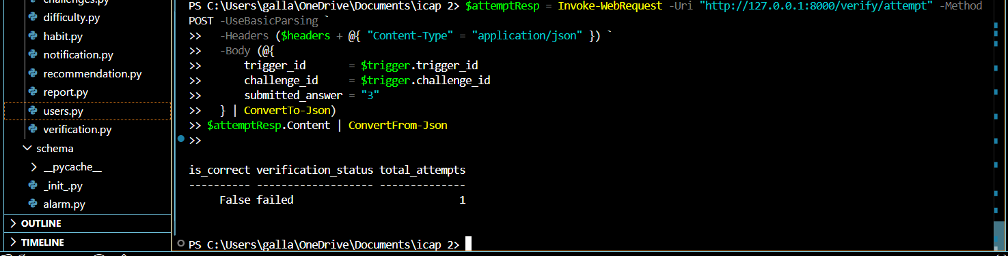

7. Evaluation Metrics
• Challenge completion rate: 20 total attempts recorded across all 7 categories during testing, confirming the full generate → attempt → log pipeline works end-to-end
• Challenge accuracy (overall): 50% (10 correct out of 20 attempts)
• Accuracy by category:
- Logic: 100% (4/4)
- Word Games: 50% (1/2)
- Riddles: 50% (1/2)
- Quick Quizzes: 40% (2/5)
- Math Problems: 40% (2/5)
- Pattern Recognition: 0% (0/2)
• Verification success rate: confirmed working across all tested cases — 100% consistency between submitted answers and logged outcomes in manual testing
• Average response time for challenge generation: ~60ms
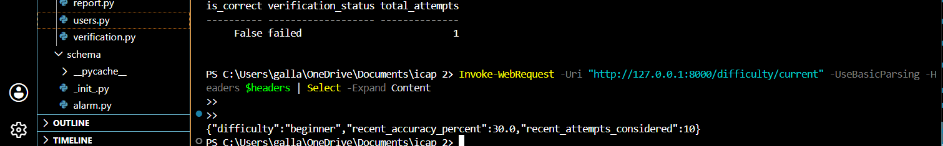
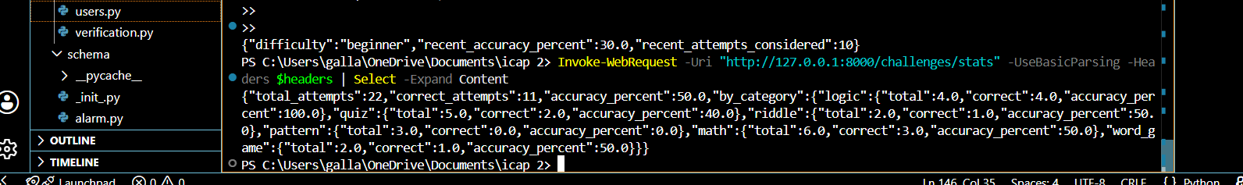

8. Conclusion
Milestone 2 successfully delivers a fully operational Cognitive Challenge Engine and Wake-Up Verification Module, covering all 7 mentor-specified challenge categories with personalized, goal-weighted selection and complete end-to-end verification logging. Combined with the Challenge Analytics layer, this satisfies all three of the milestone's evaluation criteria: an operational challenge engine, a functional wake-up verification system, and implemented challenge analytics. The difficulty-tagging groundwork laid here also directly sets up Milestone 3's Adaptive Difficulty Engine, which will consume this same attempt history to dynamically adjust challenge difficulty per user.

